Mount Lourdes GRAMMAR SCHOOL
ENNISKILLEN

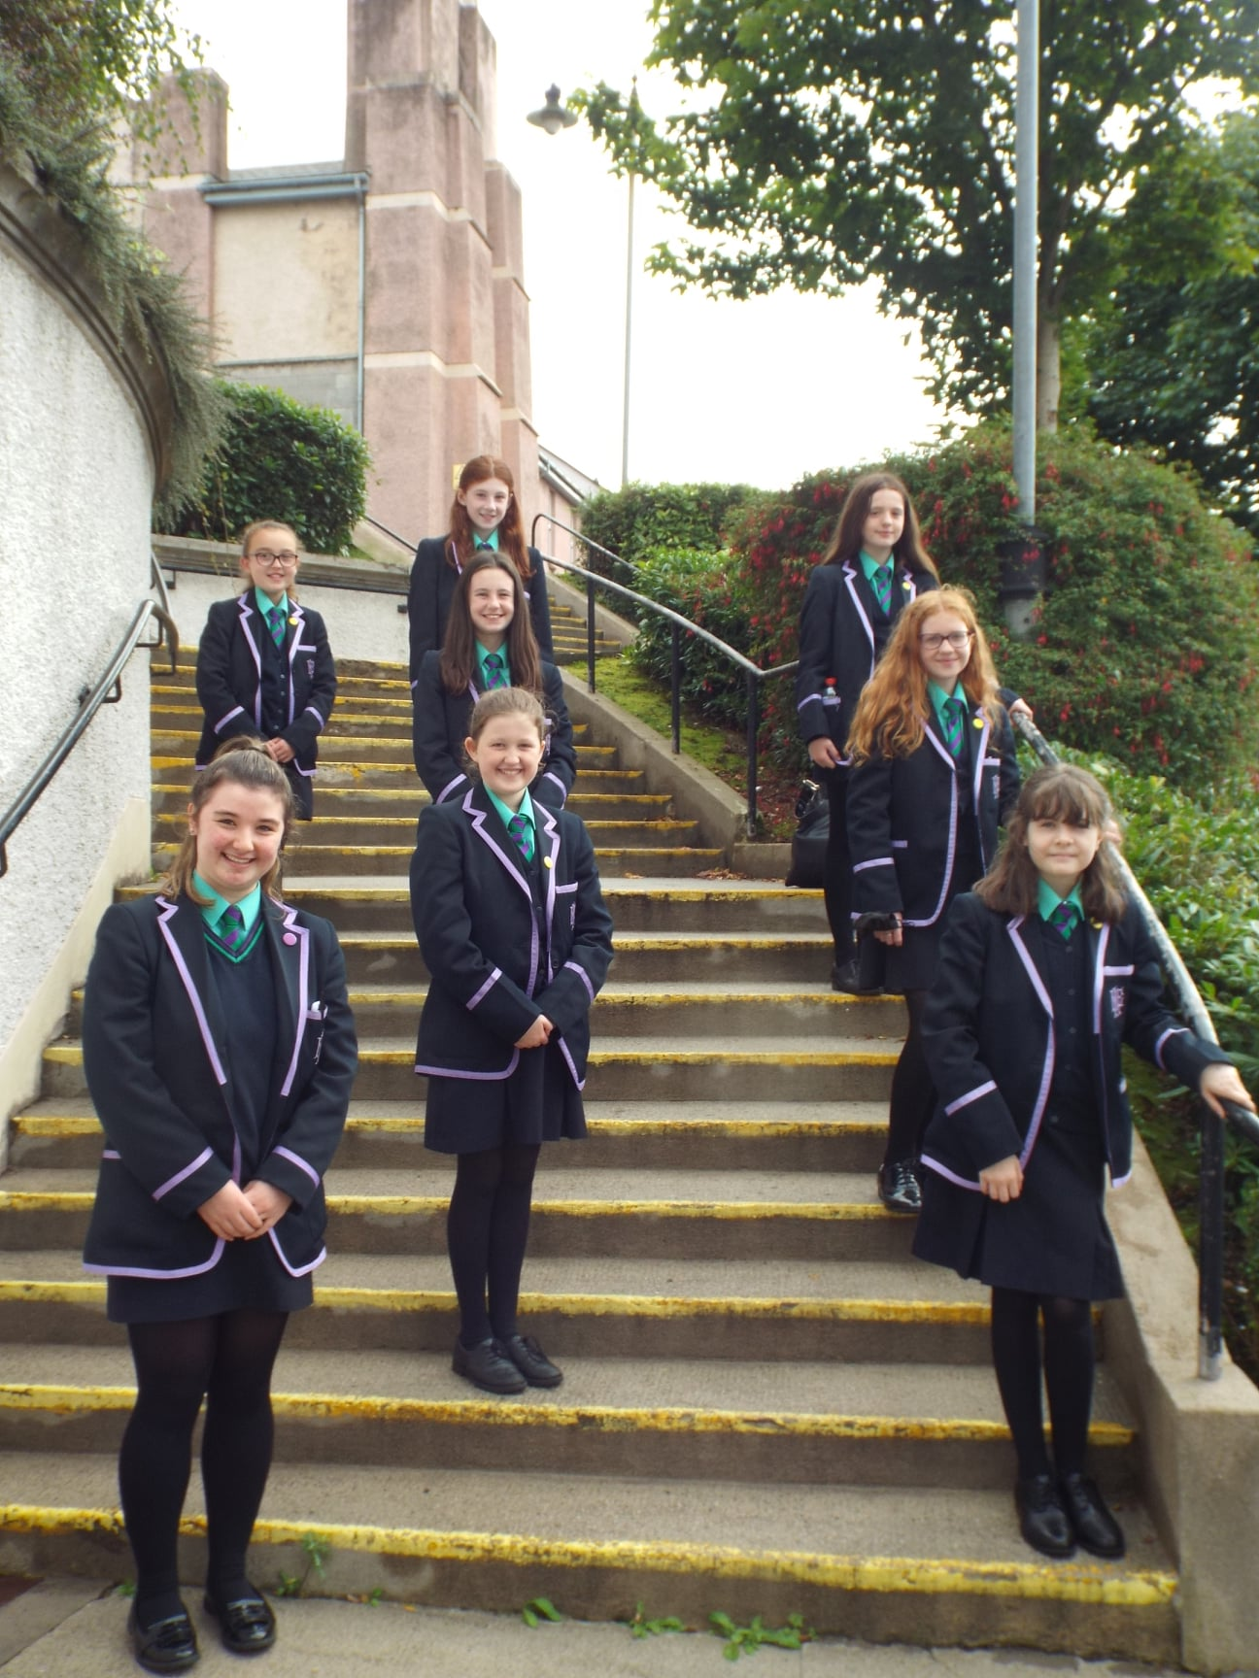


Information for Year 8 Students, Parents & Guardians
2026-2027

This is an exciting and significant event in the life of your daughter and you have a very important role in supporting and helping her prepare to change schools.

Concerns that your daughter might have could include:

- Friendship changes.
- Getting lost in the new school.
- Getting to school and back (especially if it involves a bus journey).
- Bringing the right books and equipment to school each day.
- Homework expectations.
- Adjusting to the demands of a wider range of subjects.

You can support your daughter by:

- Reassuring her that these feelings are normal and that given time she will adapt to her new school environment.
- Encouraging her to extend her group of friends.
- Encouraging her to participate in extra-curricular activities.
- Taking an active interest in her schoolwork.
- Checking her Homework Diary and ensuring that work is completed on time and to the best of her ability.
- Providing a quiet place for your daughter to do her homework.
- Encouraging her to co-operate fully with the school rules, including school uniform, punctuality and attendance.
- Communicating with the Form Teacher if you have any concerns.
- Monitoring closely the use of the internet and mobile phones so that they do not impact negatively on her personal and school life.

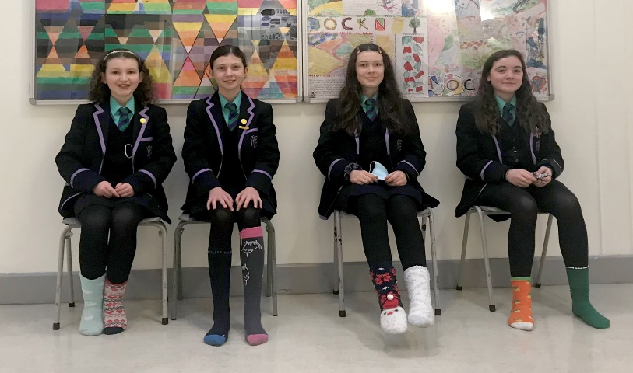

We are wearing odd socks to celebrate Anti-Bullying week in a positive way!
Your First Day: tuesday 1ST September 2026
Items to bring with you:
- A healthy snack for break.
- Packed lunch or ensure money is credited to iPay for canteen.
- Voluntary contribution: £75 per pupil or £150 per family.
- A bag in which to carry your books, stationery and pencil case.

On your first day in Mount Lourdes, Year 8, Year 11 and Year 13 students will be the only students present. You will have ample opportunity to look around the school and familiarise yourself with your new surroundings. Year 8 prefects and Form Teachers will help you find your way, so there is no need to feel anxious about getting lost.

On Your Arrival:
- Prefects will meet and guide you to the Assembly Hall.
- 8.50am: Year 8 Welcome in the Assembly Hall.
- At the end of Assembly, you will be accompanied by your Form Teacher and prefect to your form room.

You will be with your form class for the rest of the day for an Induction Programme, including:

- Participating in a range of activities to get to know the other girls in your form class.
- Understanding your timetable.
- Using your Homework Diary.
- Understanding the school rules and code of conduct.
- Learning how to deal with everyday concerns.

You will also:

- Receive your stationery, timetable and homework diary.
- Become familiar with the canteen and the cashless catering system.
- Have a tour of the school, following your first day’s timetable.
- Have your photo taken.
- Find out where your bus leaves from.

There will be no subject classes on your first day in Mount Lourdes

School Timetable 2026-2027

8.50 – 9.05am | Morning Registration
9.05 – 9.40am | Period 1
9.40 – 10.15am | Period 2
10.15 – 10.50am | Period 3
10.50 – 11.10am | Break
11.10 – 11.45am | Period 4
11.45 – 12.20pm | Period 5
12.20 – 1.00pm | Junior Lunch
1.00 – 1.40pm | Period 7
1.40 – 2.15pm | Period 8
2.15 – 2.50pm | Period 9
2.50 – 3.20pm | Period 10
3.20pm | School day finishes for Year 8 students

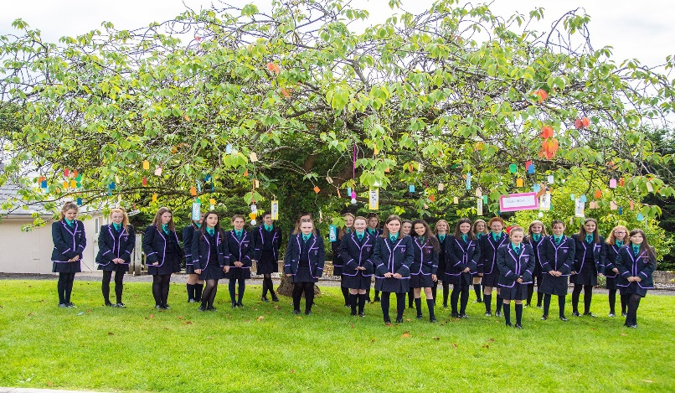
Making a wish on our first day at Mount Lourdes.

Canteen

- The canteen is open for breakfast from 8.30am to 8.50am.
- In the canteen you may choose from a varied menu of hot and cold food such as soups, stews and curries, sandwiches, paninis and wraps as well as hot and cold drinks.
- The canteen uses a biometric (fingerprint) cashless system. We have an online payment facility.
- Students who are eligible for free school meals will have £3.34 automatically added to their accounts daily.
- Year 8 students who bring a packed lunch to school can eat in the canteen, or at the picnic benches outside.

Bus

- In September bus prefects are assigned should your daughter need help.

Bus Passes

- If eligible, your bus pass will be issued to you on your first day in Mount Lourdes.
- The bus driver will not expect you to have a bus pass on your first morning.
- Keep your pass safe at all times and show it to the driver when you board the bus.
- If you lose your bus pass during the school year, you must report the loss immediately to Mrs McCaughey (Administration Staff).
- Translink charge a fee for a replacement pass.



Forever blowing bubbles in Science Club!
Important Contacts in Mount Lourdes
Your Form Teacher

Every student in the school belongs to a Form Class. You will meet your Form Teacher for Registration and Morning Assembly at 8.50 am.
You will also have two classes of Learning for Life and Work per week with your Form Teacher. This is a good time to ask questions about matters that concern you. Your Form Teacher is here to help you settle into your new school and to make it easier for you to make progress in your studies.

If you are having difficulties of any kind, it is important that you tell your Form Teacher as soon as possible.

Parents/guardians should note that the Form Teacher is also your first point of contact if you have any queries or concerns about your daughter.

Head of Year 8: Mrs Catherine Conroy (Room 25)

Form Class | Form Teacher | Room
8A | Mrs Catherine Conroy | 25
8B | Mrs Jennifer Hughes | 33
8C | Mrs Kiera Owens | 59
8D | Mrs Brenda Shannon | 5

Principal: Mrs Sinead Cullen

Head of Pastoral Care: Mrs Shauna Rice (Room 22)

SENCO: Mrs Mary Keaney

Student Counsellor: Ms Aine Martin (Familyworks)

Reception: Ms Edel McGlone

Housekeeper in charge of Sick Bay: Mrs Rita Doran & Mrs Maggie Nolan (Staffroom /Sick Bay)

Bus Passes: Mrs Ann McCaughey

Lost Property: Mrs Sara Joniec
General Information

Packing Your Schoolbag

- Students are advised to consult their timetable every evening and to pack their bag accordingly.
- Year 8 students should avoid over packing bags and only bring material for the subjects listed on their timetable for that specific day.
- It would be helpful if parents could check the contents of the schoolbag until students become familiar with the routine.

Students’ Property

Students have a responsibility to safeguard their own property and the property of others. All property and clothing must be clearly marked with the name of the owner. Students are responsible for their own possessions.
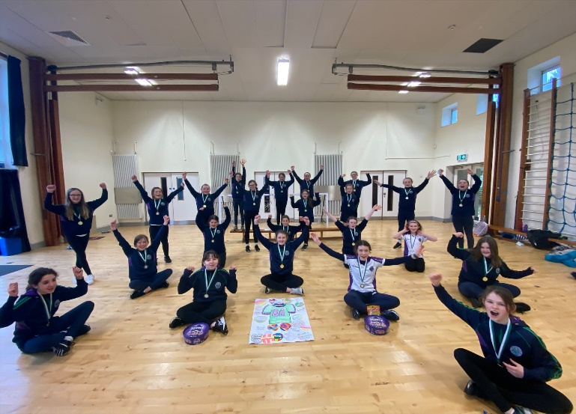

8A Winners of the Netball Tournament.

Music Tuition

Lessons can be arranged through the Music teachers and are taught on a rota basis during normal lesson time.
The school’s charging policy is available on request.

Personal Development Programme

Personal Development is delivered by the Form Teacher once a week and covers the key concepts of Self-Awareness and Personal Health and Wellbeing. In Year 8, students cover themes including Induction, Self-Concept, Managing Change, Health and the Whole Person, Managing Influences and Making Decisions. In order to make this programme more effective, parents are encouraged to discuss the issues covered in class with their daughter.

Counselling

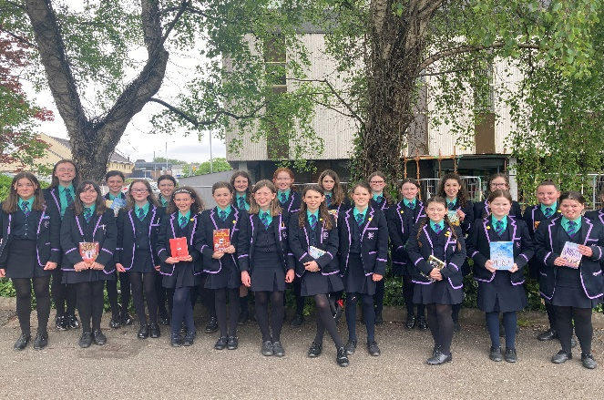
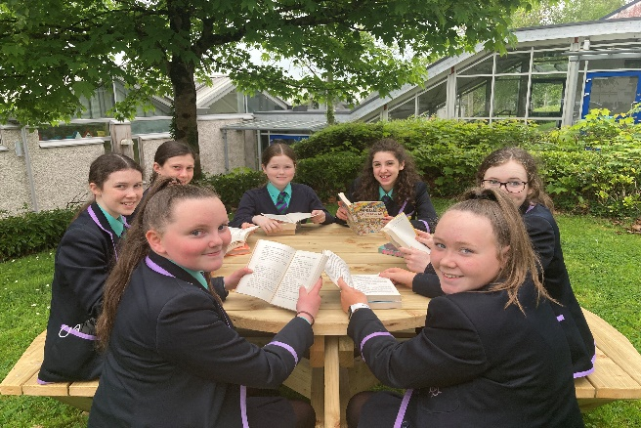
A counsellor from Familyworks Counselling Service is available in school one morning a week. If your daughter has a concern of any nature and would like to talk it over with the Counsellor, she should ask her Form Teacher or Head of Year to arrange a meeting. There is also a self-referral box available located close to the Library. A parent may also request an appointment with the counsellor on behalf of their daughter.

Child Protection / Safeguarding

Mount Lourdes places great importance on ensuring the safety and well-being of all students. The school’s Child Protection policy operates in line with Department of Education regulations and Safeguarding guidelines.

Designated Teacher for Child Protection: Mrs Michelle Judge
(Vice Principal)

Deputy Designated Teachers: Mr Gerard Quinn (Senior Teacher)
Mrs Sinead Cullen (Principal)

Anti-Bullying

We pride ourselves on having a happy school where everyone respects others’ views and opinions and feels part of the school community. We place great emphasis on dealing effectively with behaviours that cause stress to others. If you have concerns about bullying behaviour you should talk to your Form Teacher and your parents/guardians about it.
Please see our school website to read our full anti-bullying policy.

Use of Mobile Phones

We understand that some parents may wish their daughter to have a mobile phone for ease of contact and for use in an emergency on the way to and from school. However, the increasing misuse of mobile phones and, in particular, the misuse of the camera and video facilities is a cause for concern. Therefore, it is necessary to draw the attention of parents and students to the following rules:

- Mobile phones must be switched off at all times during the school day.
- Phones must never be used to take photographs or video footage in school, on the bus or during school related activities/trips.
- Phones, watches and electronic devices are not permitted in the exam room for internal or external examinations.
- We would ask parents not to phone or message students during school hours.
- In exceptional circumstances, parents who need to contact their daughter during the school day, should do so by telephoning the Main Office.

Please see our school website to read our full mobile phone policy.

Attendance: Miss School = Miss Out

Every single day a young person is absent from school equates to a day of lost learning. Attendance percentages can be misleading. For some parents 90% may seem like an acceptable level of attendance, but the reality is that 90% attendance means that your child will miss half a school day each week or 19 days of school during the school year – that’s nearly 4 school weeks.

Give your daughter the best start in life; every school day counts.

The table below will guide you:

100% Attendance | 0 Days Missed | Excellent
95% Attendance | 9 Days of Absence  1 Week and 4 Days of Learning Missed | Satisfactory
90% Attendance | 19 Days of Absence  3 Weeks and 4 Days of Learning Missed | Poor
85% Attendance | 28 Days of Absence  5 Weeks and 3 Days of Learning Missed | Very Poor
80% Attendance | 38 Days of Absence  7 Weeks and 3 Days of Learning Missed | Unacceptable
75% Attendance | 46 Days of Absence  9 Weeks and 1 Day of Learning Missed | Unacceptable

Procedures

- If unavoidably absent from school, a student, on her return, must provide her form teacher with two copies of a letter explaining the absence. This letter should be signed by her parent/guardian.
- If you are absent for three consecutive days, your parents/guardians may receive a courtesy telephone call from the Form Teacher. This protocol ensures good home school communication and enables the school to provide appropriate support when necessary.
- Parents/guardians will be contacted if a student’s attendance is giving cause for concern. If there is no improvement in the student’s attendance, a referral may be made to the Educational Welfare Service.
- Family holidays should not be organised during term time.

Arriving late to school

If you arrive late because you have had a doctor’s/dentist’s appointment, then you must bring a note to that effect from your parents/guardians. On arrival, you must report to your Form Teacher to be registered.

Permission to leave the premises during school hours

Students must not leave the premises during school hours without permission. Requests to have time off from lessons should be kept to an absolute minimum. They should only be made when medical or dental appointments cannot be secured outside of school hours. The school actively discourages requests for time out to attend social events.

When permission to leave school is necessary, a student is required to:

- Present a letter of explanation dated and signed by the parent/guardian to the Form Teacher before or during registration on the day of the planned absence and obtain a permission slip.
- Receive a signed permission slip from the Form Teacher which must be produced on request.
- Go to her normal class on her return to school (if the absence is for part of a school day only).
- In exceptional circumstances a parent may need to phone the school to request permission for his/her daughter to leave during the school day. Should this arise, the student must be signed out by the Head of Year in the usual manner.
- Students may not leave school in response to a call that has not gone through agreed channels of communication; should this occur; sanctions will be applied in line with the Positive Behaviour Management Policy.

Feeling unwell during the school day

- If you are feeling unwell in school, you must first ask permission from your teacher to visit the sick bay.
- When you leave the classroom, you must go immediately to Mrs Doran/Mrs Nolan (Sick Bay Attendant) who is available in the Main Staffroom.
- If you need to go home, your parents/guardians will be contacted by a member of staff and asked to collect you at the Main Office.
- Students must not make any independent arrangements via a mobile phone.

Positive Behaviour Management

The school endeavours to establish a community in which the full potential of each person can be developed and in which understanding and tolerance are found. It strives to promote respect for the individual and to create an atmosphere in which learning can take place.

Good behaviour by students is essential if the school is to fulfil its function. To encourage a high standard of behaviour, the school takes a positive approach, employing praise, encouragement, and rewards. It also places great importance on the formation and maintenance of good relationships between all members of the school community.

To ensure the safety of the students and the smooth running of the school there are rules which we require the students to follow. Failure to observe these rules incurs sanctions as part of the school's referral system.

School Rules

These rules apply not only within school, but also when travelling to and from school, and outside school hours when students are part of an organised school group.

- Students must show a high standard of courtesy to everyone, staff, fellow students and others at all times. Under no circumstances may a student interfere with, threaten or strike any other person connected with the school.
- Students must not trade in, possess, or use tobacco, alcohol or any illegal substance within the school or school grounds.
- Students are required to wear the regulation school uniform neatly at all times. While doing so they are representing the school and all school rules must be observed.
- Students are required to treat all property within school with care. If property is damaged or lost, students will be expected to pay the cost of repair or replacement.
- Students must not enter laboratories or practical rooms unless a teacher is present. Classroom equipment is not to be used without the permission of a teacher.
- Students are expected to keep mobile phones switched off during registration and all classes. Infringements of this rule will lead to the confiscation of the phone. Students are not permitted to use the camera facility on their phone in school or during school related activities.
- IPods should not be used in school, in the school grounds, or on the way to and from school.

Referral System

- All members of the school staff work to promote positive behaviour in the school. Minor infringements are dealt with by the teacher in charge of the class.
- In more serious cases a student may be spoken to by her Form Teacher or Head of Year or Senior Teacher who may impose an appropriate sanction.
- Repeated or very serious offences are dealt with by the Vice-Principal or a Senior Teacher. If appropriate parents will be informed and are expected to ensure that the student’s future behaviour is acceptable.
- Sanctions imposed may include lunchtime or after school detentions. A letter will always be sent home if after school detention is given. In such instances it will be the parent’s/guardian’s responsibility to make appropriate travel arrangements for their daughter.
- In the most serious cases students may be suspended by the Principal.
- The Board of Governors has the authority to exclude any student who is persistently infringing the school rules. Those found to be trading in illegal substances will be excluded.

Homework

Homework plays an essential part in helping all students achieve their full potential. It helps to develop student responsibility by encouraging independent learning and encourages life-long learning.

Homework is set primarily to:

• Develop the habit of independent study.
• Reinforce and extend what has been learned in the classroom.
• Build on the Assessment for Learning approach used in the classroom.
• Provide an indication of student progress.
• Help students prepare for future lessons and assessments.

The recommended minimum homework time for Year 8 students is 1 hour 30 minutes. When homework has been completed, the remaining time should be devoted to personal study or revision. Students are discouraged from having access to their mobile phones during homework time.

Homework activities may include reading, essay writing, summarising, learning, preparing a presentation, carrying out research, listening to a podcast, making something, revising, answering questions, catching up on work missed due to absence from lessons.

Homework Diary

Each student in Mount Lourdes is given a Homework Diary at the beginning of the school year to record details of homework set and to help ensure that deadlines are met. The Homework Diary should be brought to every lesson and the following practices are encouraged:

• Record homework on the date it is given.
• Record the due date of the homework.
• Keep the homework diary neat and tidy.

The Homework Diary also contains some important information for parents/guardians regarding School Policies and Procedures and useful reference material for individual subjects.

It is the responsibility of every student to ensure that they catch up with any work missed through absence from class.

Assessments

During the year you will be given assessments in all subjects. These assessments may take the form of a class test, a particular piece of homework, a project or they may be based on a series of homework. Each assessment will help your teachers monitor your progress and may contribute to your report grade. Year 8 students will have an internal exam period in December and June. Revision lists and an exam timetable will be provided to students before the exam season.

How can I help my daughter with her learning?

Getting involved with your daughter’s education can make a significant difference to her chances of success. Research has shown that students whose parents are involved get higher marks, have a better attitude towards learning and develop more confidence. As your daughter gets older, she needs to become more independent. However, offering lots of encouragement will get her off to the right start:

- Be interested and talk to your daughter about what she has learnt in school.
- Encourage your daughter to complete her homework as soon as it has been assigned.
- Turn off the television and mobile phones while homework is being completed.
- Ensure your daughter has the right books and resources.
- Discourage your daughter from copying without editing when she is asked to carry out research.
- Help your daughter to become an independent learner. Explain how to look up information rather than simply giving her an answer in order to get the task finished.
- Encourage your daughter to talk to her teacher about her learning.
- Read carefully any comments that your daughter’s teachers make about her work.
- Make every effort to attend Parent Teacher Meetings.
- Encourage a balanced approach to schoolwork and achievement.

Mount Lourdes encourages parents/guardians to become fully involved in their daughter’s education. However, please do not be tempted to do her homework for her. If your daughter is to progress, we need to know how much she understands and can do independently.
Uniform
The school uniform is designed to foster a sense of belonging, loyalty and pride and is set within the context of the School Pastoral Care Policy and Positive Behaviour Management Policy. Students are required to wear the school uniform with pride throughout the day, when travelling to and from school and on all occasions when representing the school. We appreciate the support and co-operation of parents/guardians in upholding our high standards regarding school uniform.

School Uniform: (Key Stage 3) Years 8, 9 & 10

Navy double- pleated knee length skirt
Navy blazer with the Mount Lourdes crest
Plain navy cardigan (optional)
Mount Lourdes clip-on tie
Plain green blouse (the top button should be closed)
Navy knee-length socks or navy tights
Plain black leather flat shoes
Mount Lourdes scarf (optional)
Mount Lourdes hat (optional)

Suppliers: S D Kells & Co, Enniskillen, Irvinestown & Lisnaskea
G Hicks & Son, Lisnaskea,
School Days, Enniskillen.

PE Uniform

Regulation PE kit is available to buy in O’Neills, Quay Lane, Enniskillen:
PE Top
Shorts
Sports trainers
Crew neck sweatshirt (optional)
Socks (optional)

Uniform Regulations

- All students must wear the school blazer to and from school and during the school day.
- Wearing of school cardigan is optional.
- Pleated skirt must be knee length.
- Students must wear flat, black shoes. Trainers, boots, stilettos, white soles, coloured or ornamented types of footwear are not acceptable.
- A plain, black or navy coat can be worn over the school blazer in poor weather conditions (no logos permitted).
- Hair colouring should be natural in shading. Pinks, greens, purples and other unnatural shadings are not acceptable. If this issue arises, parents/guardians will be contacted to ensure that hair colour is returned to a natural shade within a brief, agreed timescale.
- Students are permitted to wear one pair of stud earrings in the lower earlobe.
- Nose, tongue, eyebrow and all other piercings are unacceptable and students will be asked to remove such items.
- Make-up, nail varnish, false, including gel and acrylic nails are not permitted in school.
- Full school uniform to be worn on all school trips, except when the nature of the activity prohibits it.
- When participating in, or travelling to school sporting activities school PE uniform should be worn. If a student does not have a school PE uniform, she should wear plain navy track bottoms and sweatshirt. No coloured or club sportswear is permitted. For health and safety reasons, students should purchase suitable trainers for sport; fashion trainers are not acceptable.
- Any item of clothing or jewellery worn against uniform regulations is liable to be confiscated.

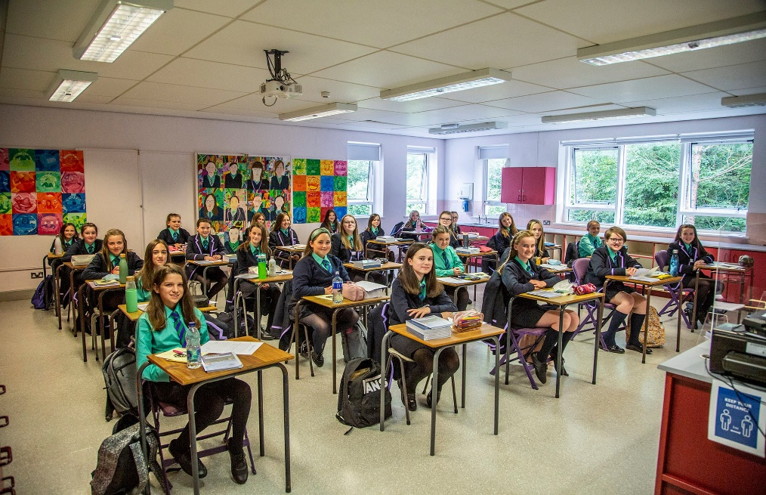

We can’t wait to continue our journey in Mount Lourdes.

Communication with Parents / Guardians

The school places great importance on developing an active partnership with parents.

Forms of communication include:
- Two annual progress reports.
- Annual Parent-Teacher meeting.
- Year 8 Pastoral Event during Term 1.
- Homework Diary.
- School text messaging system.
- School website https://www.mountlourdes.com/
- School Facebook Page.
- Letters/phone-calls home as required.
- Parent App.

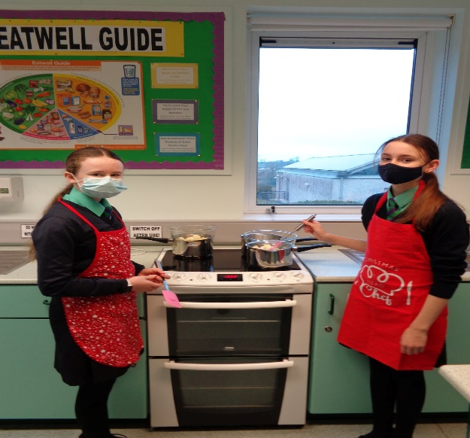 | 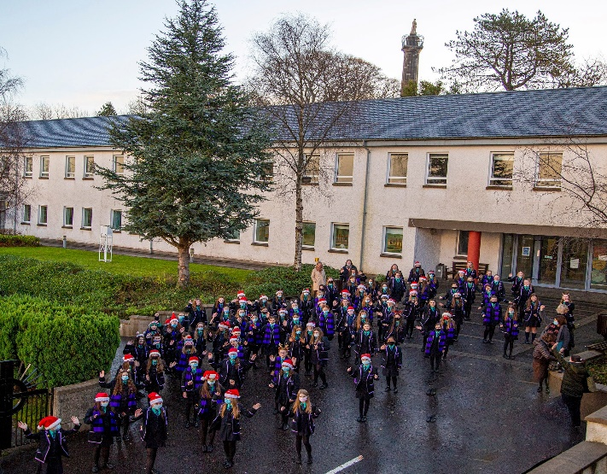
Cooking up a storm in Home Economics! | Getting into the Christmas Spirit at MLE.


Memories From Year 8

School Holidays 2026-2027
Tuesday 1st September | Years 8, 11 & 13
Wednesday 2nd September | Years 9, 10, 12 & 14  (Year 8, 11 & 13 do not attend school today)
Thursday 3rd September | All year groups attend school
 | Autumn Term | 1st September - 21st December
 | Closings | 25th September  23rd October  26th October to 30th October  25th November
 |  | 22nd December to 4th January
 | Spring Term | 4th January - 26th March
 | Closings | 25Th January  8th February to 12th February  25th February
16th March & 17th March

25th March to 2nd April

 | Summer Term | 5th April - 30th June
 | Closings | 5th April  3rd & 4th May

(The school calendar will be updated at regular intervals throughout the year. Please refer to our website at www.mountlourdes.com)

