Mount Lourdes Student Council
Progress Bulletin – 2024/2025

This bulletin has been produced by the Student Council to summarise some of the key issues addressed at formal Student Council meetings over the past academic year, actions taken, and progress made to date.



Election
Day

School Canteen
Councillors Niamh McAllister, Matilda McDaid and Ellie McCaffrey were appointed to lead on student issues around Canteen efficiency (queues), payments and advertising. Students were very happy with canteen food quality and variety but felt that canteen processes could be speeded up to improve customer service. Student Council meetings with Claire (Cook Supervisor) during the year focused on enabling students to know menu choices in advance, so that less time was wasted making on the spot choices, at the food counter.
A new ‘fixed’ menu of common menu choices was agreed and a schedule drawn up which was advertised on the school web site, social media, Parent App and I-Pay Impact App. This enables better communication to students and parents. A new notice board of ‘daily specials’ was erected at the Canteen entrance to advertise choices in advance of ordering. A message went out to all students and parents advertising the I Pay Impact App for easier, more efficient payment options. One of Claire’s targets for the near future is to run a trial ‘pre-order/collect’ system to further extend the range of Canteen services to students. The Canteen wishes students and parents to know that they try to cater for all requirements, so where students have special dietary needs, please alert Claire personally or through form teachers to see how individual needs can be catered for.

Niamh, Matilda and Ellie discuss progress with Claire
New Mount Lourdes Rugby Half-Zip
Year 12 councillors brought forward the suggestion of the introduction of a new school Rugby half-zip. Jessica Gavin took responsibility for leading this initiative. Over the year, Jessica collaborated with MFC Sports in relation to the planning and production of a lovely new half-zip for Mount Lourdes Rugby students. Jessica updated the Student Council and SLT throughout the process regarding progress. The new half-zips have proved extremely popular. Congratulations to Jessica for showing such great initiative and leadership in making this happen.
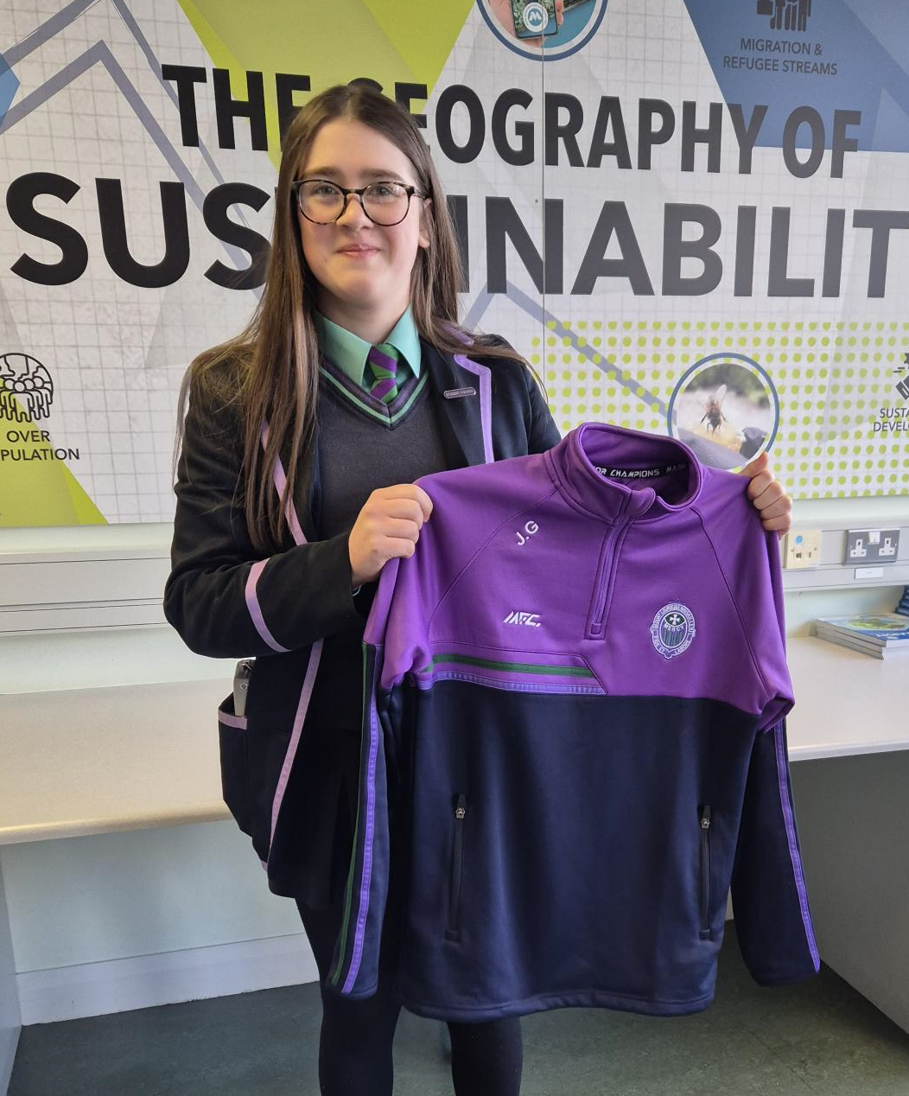
Jessica showing the finished product
Toilets Maintenance
Councillors from several year groups raised the issue of toilet cubicles being out of action due to damaged locks or plumbing related issues. Ava Kilpatrick met with Mrs M Cosgrove (Cleaning Supervisor) concerning this issue. An audit of all toilets in Mount Lourdes was carried out in January 2025, with results fed back to the Student Council meeting in February. Mrs K Colton (Bursar) arranged to have the necessary maintenance carried out. Thanks to Mr Kevin McManus (Caretaker) for helping with this process. As a result, maintenance has been carried out on the toilets concerned. Also, this issue was forwarded to the school’s Health and Safety Meetings where it helped to secure the appointment a school maintenance contractor. This appointment was made in July 2025.
Student Council Meeting in Action – February 2025.
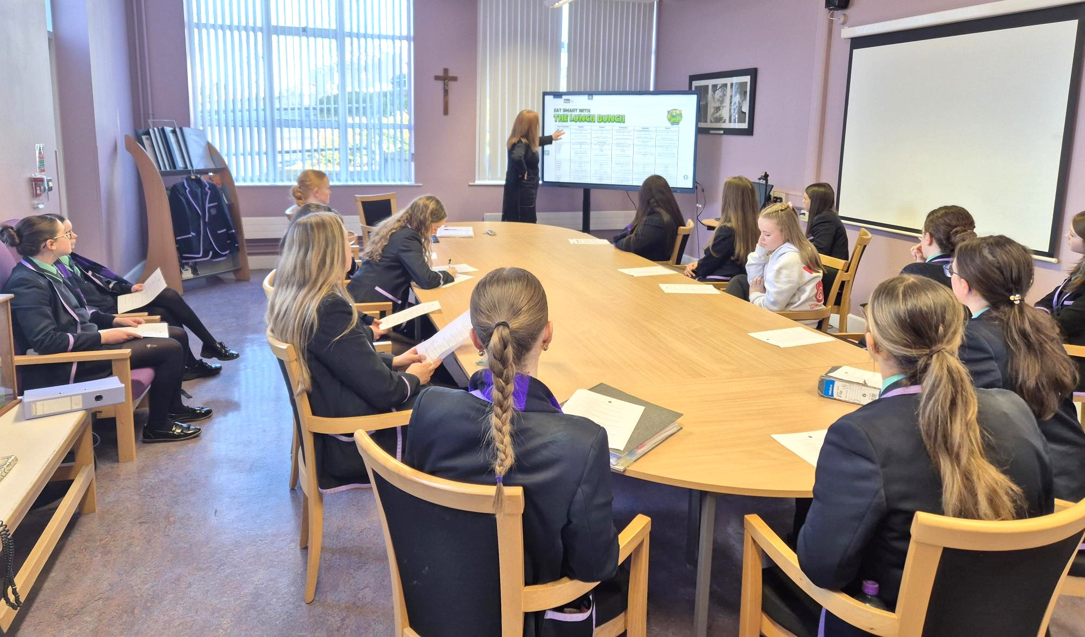

School Policies Evaluation
The Student Council was consulted about a number of new school policies in 2024/25. The new Assessment Policy – involving new set periods for Christmas / Summer Exams for all year groups, was discussed and evaluated in November 2024 (student views before new Christmas Exams) and in late December 2024 (students views after exams). The results of the Student Consultation were discussed with Mrs Cullen at the February 27th Student Council Meeting. The new policy received an overwhelming vote of confidence, while a number of useful suggestions for improvement next year were noted for discussion by SLT.
The Mobile Phone Policy was once again discussed and evaluated. All year groups represented on the Student Council expressed support for the new policy with great emphasis on the benefits for student mental health, concentration levels and student conversation/ social skills in general. Year 13 and 14 students particularly liked the fact that phones can be used in class for educational benefit, at the teachers’ discretion; using the phone in a way which benefits learning and teaching.

Finally, the Student Council was used to evaluate the school’s Period Dignity Policy. Councillors answered a Period Dignity Audit which informed the school’s pastoral care future planning.

Uniform Related Issues
Year 9 councillors brough forward the suggestion of students wearing PE Kit into school for students who had PE Period 1. Mrs Cullen advised the Council that this is a recurring student suggestion and as such has been discussed frequently at SLT. The Mount Lourdes uniform is a key way in which the school’s tradition, identity and values are represented to the wider public. Wearing of PE kit into school could undermine the school’s high uniform standards as well as the school’s image with the general public, particularly if student’s wear casual alternatives to the school’s colours. Parents spent a lot of money on the school uniform and so expect to get value from the uniform.
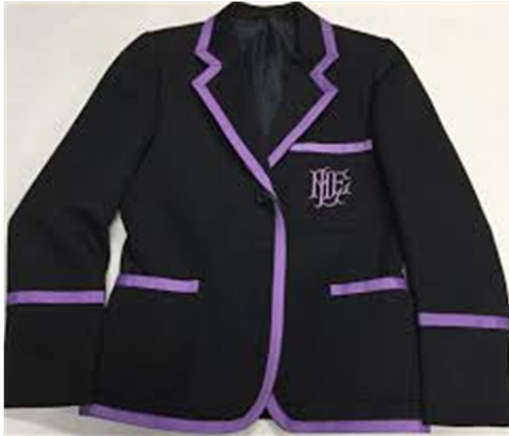
The Student Council were shown samples of a Mount Lourdes school blazer produced by a local uniform supplier, at cheaper cost to parents. Councillors were impressed by the look and feel of the alternative blazer. Discussions were had around longer-term quality. Traditionally, Student Councillors have needed to purchase two blazers over seven years of education. Quality of the product has been excellent. Councillors agreed that it was very beneficial for parents to have options. Mrs Cullen asked Councillors to promote the school’s Uniform Exchange which is available throughout the year and often offers nearly new uniform items for free.
Cheaper Blazer Alternative
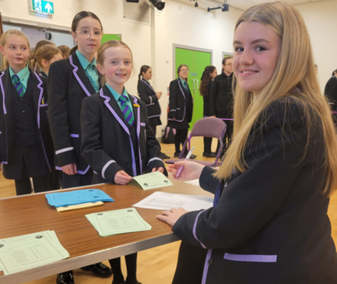
Thank You
We thank all who represented their year groups so well on the Student Council of 2024/2025. The councillors involved did themselves, their families and the school proud. Over the coming weeks, the process of electing new Student Councillors for Year 8 and Year 13 will occur. Membership of the Mount Lourdes Student Council is a great honour and a real opportunity to make change happen in school. It is also an excellent opportunity to develop leadership and teamworking skills. Good luck to all who stand for election.


